Eyeconic - Glasses Shop Management System

Use-Case Specification: Edit Contact lens

Version 1.1

Revision History

|  |  |  |  |
| --- | --- | --- | --- |
| **Date** | **Version** | **Description** | **Author** |
| 05/11/2019 | 1.0 | Start creating use case | Đỗ Nguyễn Hoàng Ân |
| 18/11/2019 | 1.1 | Dix use case | Đỗ Nguyễn Hoàng Ân |
|  |  |  |  |
|  |  |  |  |

Table of Contents

**Edit Contact Contact lens** **4**

Brief Description 4

**Flow of Events** **4**

Basic Flow 4

2.2 Exception 5

2.2.1 Edit Contact Contact lens 5

2.2.2 Fill in the Contact lens information 5

**Special Requirements** **5**

**4 Preconditions** **5**

4.1 Admin must be logged in 5

**5. Postconditions** **5**

**6. Extension Points** **5**

Use-Case Specification: Edit Contact lens

# Edit Contact lens

## Brief Description

This use case defines the step of removing existing Contact lens from the database.

Contact lens are removed by the administrator.

# Flow of Events

## Basic Flow

The system administration selects the Contact lens data to edit. The administrator changes the needed information. The system displays the updated management parameter value and logs the change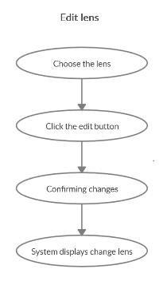

***Basic flow of Removing Contact lens***

Step 1: Choose the Contact lens you want to edit

Step 2: Click edit button

A modal view shows up

Edit the change needed

Step 3: Confirming adding the Contact lens by clicking the “Save” button.

Step 4: Successful information changed Contact lens are displayed on the screen

## 2.2 Exception

### 2.2.1 Edit Contact lens

The add button cannot be clicked or isn’t appeared on the screen

### 2.2.2 Fill in the Contact lens information

Invalid information.

2.2.3 Confirming editing the Contact lens

The “Save” button is clicked but the new information of the Contact lens are not changed.

2.2.4 System displays added Contact lens

The edited Contact lens’ information are not displayed correctly.

# Special Requirements

No Special Requirements

# 4 Preconditions

## 4.1 Admin must be logged in

User must already login as the administrator of the website

# 5. Postconditions

. Contact lens information is changed and can be purchased by customers

# 6. Extension Points

Administrator check the website and the system to ensure that the edited information of the glasses is correct.